**ACCESSIBILITY GUIDELINES PROVIDED BY IOS**

**HUMCOM1**

**FEBRUARY 25, 2021**

**Accessibility**

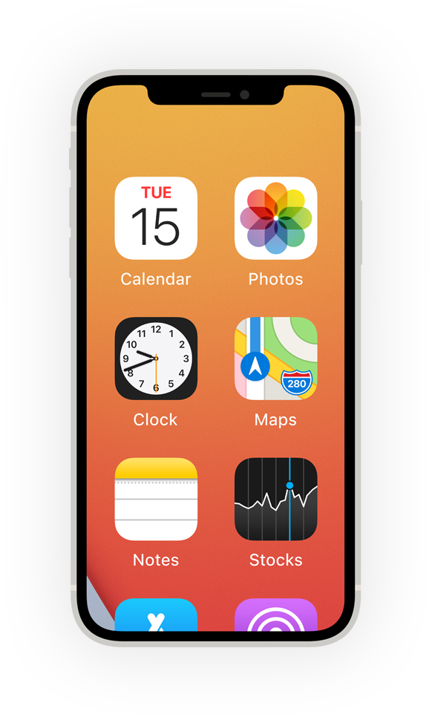**Built‑in features that work the way you do. Make them yours, and make something wonderful.**

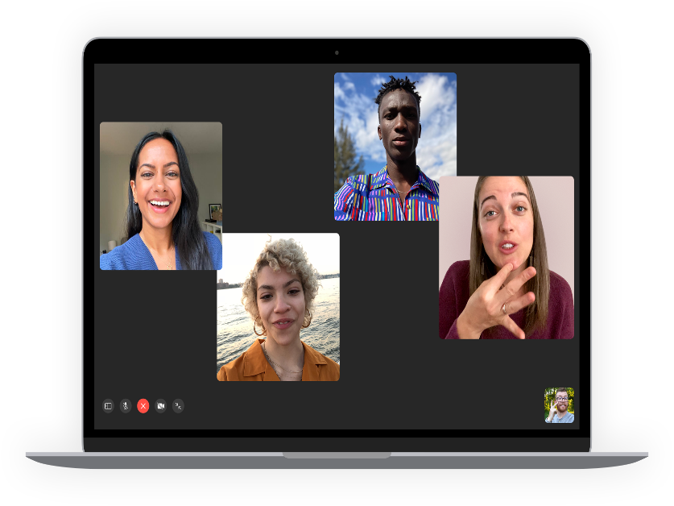

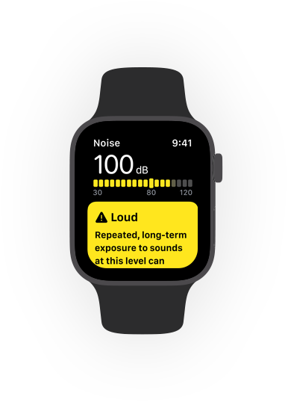

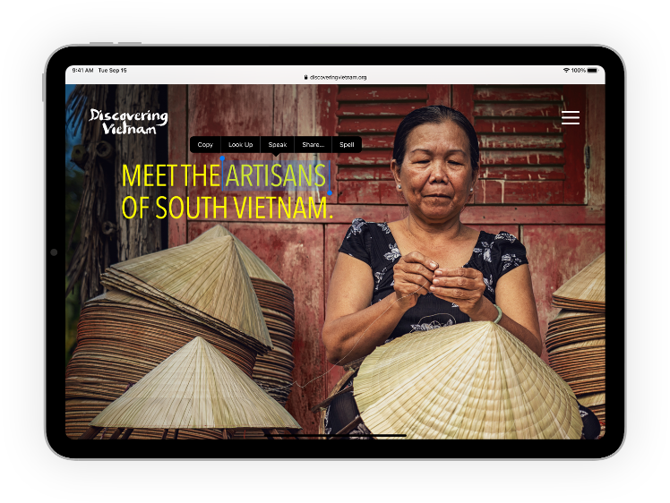

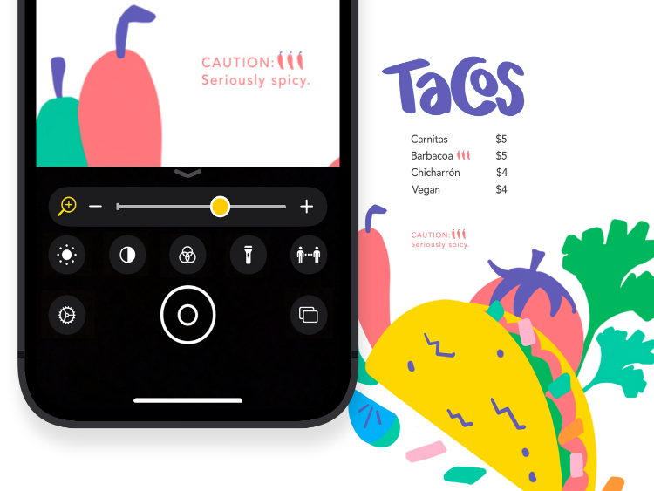

**Set the text just right.**

Ahttps://www.apple.com/v/accessibility/p/images/overview/larger_text_scale__edl7ta3u47ee_large_2x.pngA

**Zoom**

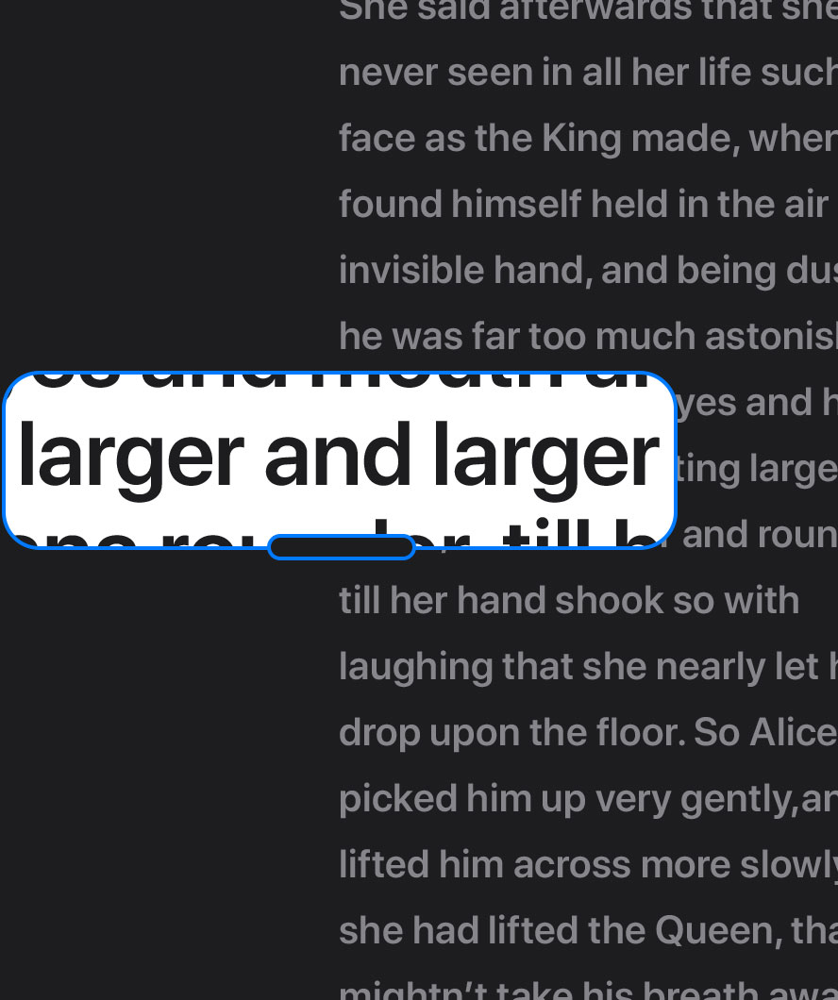

about Zoom

[**All vision features**](https://www.apple.com/ph/accessibility/vision/)

**All it takes is a tap.**

**Switch Control**

**Switch the way you move.**

**Back Tap**

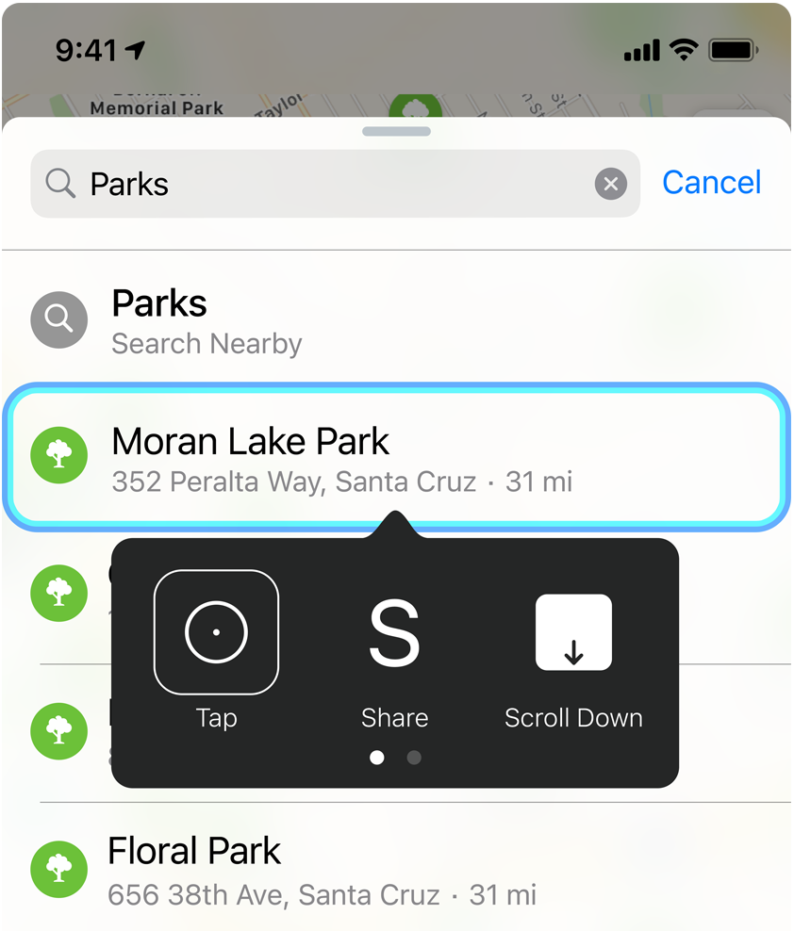**Tap-tap here.**



**Cue  
magic  
here.**

**AssistiveTouch**

Read more about AssistiveTouch

[**All mobility features**](https://www.apple.com/ph/accessibility/mobility/)

**Hear. There. Everywhere.**

**Headphone Accommodations**

**Make a sound decision.**



**Made for iPhone hearing aids**

**Match your levels to your location.**

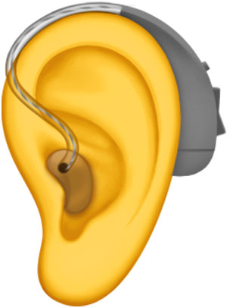

**Live Listen**

**Front‑row sound.**

**All the way  
from the back.**

[**All hearing features**](https://www.apple.com/ph/accessibility/hearing/)

**Create your own  
center of attention.**

**Safari Reader**

**Be captivated by content, not clutter.**

**Spoken Content**

**Turn assigned reading in to easy listening.**

[**All cognitive features**](https://www.apple.com/ph/accessibility/cognitive/)

**Screens that speak volumes.**

**Voice Over**

**Puts moments into words.**

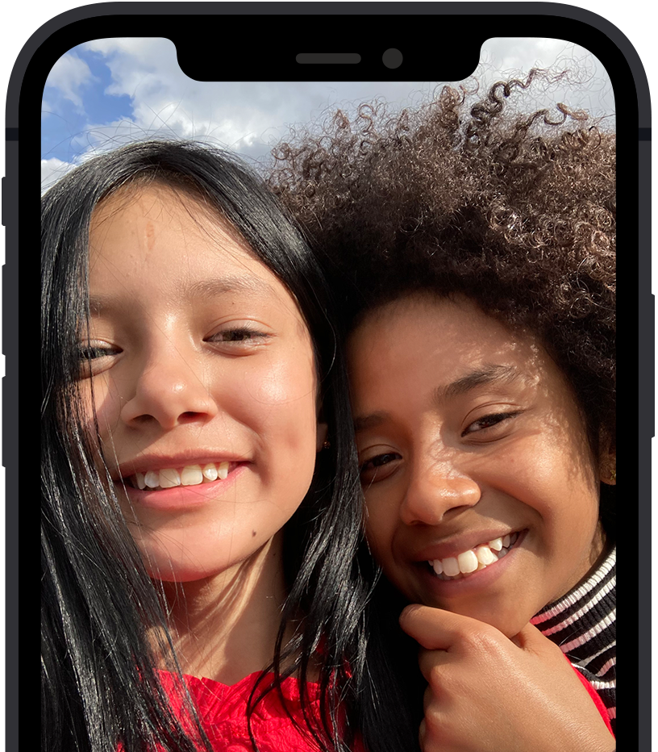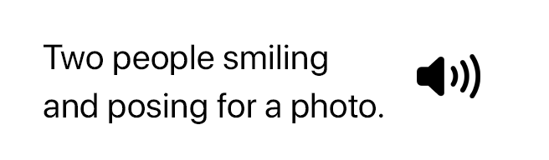

**Audio Descriptions**

**Descriptions that really make a scene.**



**Speak Selection**



**This feature speaks for itself.**

[**All vision features**](https://www.apple.com/ph/accessibility/vision/)

**Say anything. Do everything.**

**Dictation**



**Shortcuts**

**There’s a shortcut  
for that.**

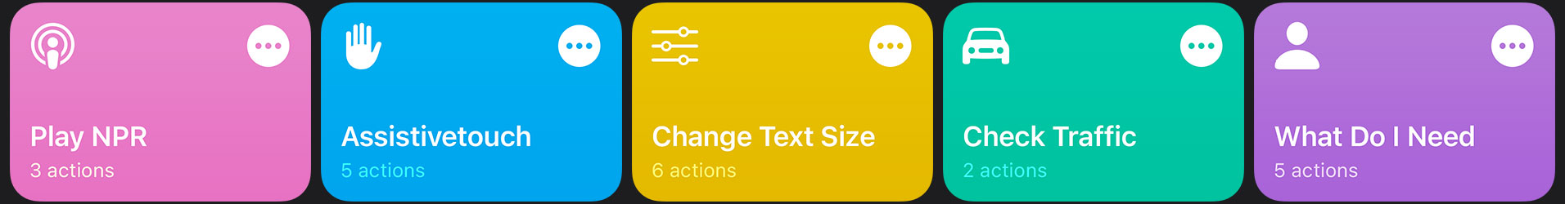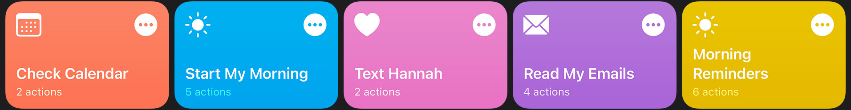

[**All mobility features**](https://www.apple.com/ph/accessibility/mobility/)

**Must-know is now can’t‑miss.**

**Sound Recognition**

**Look down for a heads‑up.**

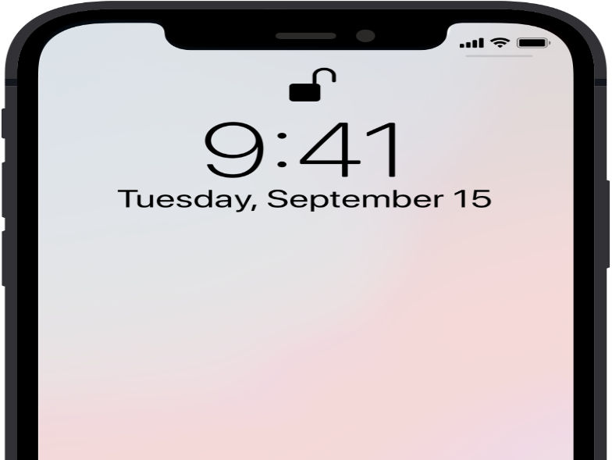

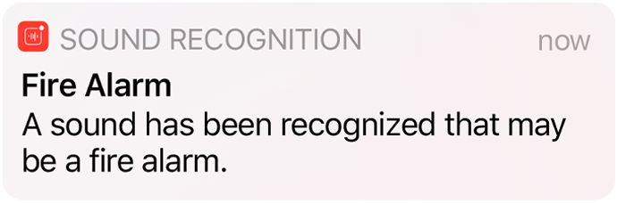

**Sensory Alerts**

**FaceTime + Sign Language Prominence**

**Your conversation, front and center.**



[**All hearing features**](https://www.apple.com/ph/accessibility/hearing/)

**Accessibility starts here.**



**Get more out of your features.**

Learn tips, tricks, and how-to’s for accessibility features straight from Apple Support on YouTube.

**REFERENCE :**

**https://medium.com/swlh/accessibility-in-android-with-material-design-code-in-mobile-d2d1df54a0b6**